PREDICTING EXPECTED EMAIL
RESPONSE TIMES

A MINI PROJECT REPORT

Submitted by

E.BRINDHA 1605064
S.ISHANI 1605079

in partial fulfillment for the award of the degree of
BACHELOR OF ENGINEERING

in

COMPUTER SCIENCE AND ENGINEERING



COIMBATORE INSTITUTE OF TECHNOLOGY
(Government Aided Autonomous Institution Affiliated to Anna University)
COIMBATORE-641 014

ANNA UNIVERSITY - CHENNAI 600 025
MARCH 2019
COIMBATORE INSTITUTE OF TECHNOLOGY
(A Govt. Aided Autonomous Institution Affiliated to Anna University)
COIMBATORE – 641 014

BONAFIDE CERTIFICATE

Certified that this mini project “PREDICTING EXPECTED EMAIL RESPONSE TIMES” is the bonafide work of BRINDHA.E(1605064),ISHANI.S(1605079) under my supervision during the academic year 2018-2019.

Dr.G.Kousalya, M.E.,Ph.D Ms.E.L.Jaya Kamachi Elangovan, M.S.
HEAD OF THE DEPARTMENT, ASSISTANT PROFESSOR,
Department of CSE Department of CSE,
Coimbatore Institute of Technology, Coimbatore Institute of Technology,
Coimbatore – 641 014. Coimbatore – 641 014.

Certified that the candidates were examined by us in the project work viva-voce
examination held on …………………

Internal Examiner External Examiner

Place:
Date:

TABLE OF CONTENTS

CHAPTER NO. TITLE PAGE NO

ACKNOWLEDGEMENT i

ABSTRACT ii

LIST OF FIGURES iii
LIST OF ABBREVIATION iv
- INTRODUCTION 1
1.1 EMAIL RESPONSE TIME 1
1.2 DATA PREPROCESSING 2
1.3 FEATURE SELECTION 3
1.4 MACHINE LEARNING 4
1.4.1 LINEAR REGRESSION 4
1.4.2 LOGISTIC REGRESSION 5
1.4.3 SUPPORT VECTOR MACHINE 5
1.5 CLASSIFICATION 6
1.5.1 CLASSIFICATION TECHNIQUES 6
- LITERATURE SURVEY 8
- SYSTEM SPECIFICATION 12
3.1 SOFTWARE SPECIFICATION 12
  - HARDWARE SPECIFICATION 12
4 SYSTEM ANALYSIS 13
4.1 EXISTING SYSTEM 13
4.2 PROPOSED SYSTEM 14
- SYSTEM IMPLEMENTATION 15
5.1 OVERVIEW 15
5.2 MODULES 15
5.2.1 CHAIN PAIR EXTRACTOR ALGORITHM 15
5.2.2 LINEAR REGRESSION 16
5.2.3 LOGISTIC REGRESSION 17
5.2.4 SUPPORT VECTOR MACHINE 17
6 RESULT 18
7 CONCLUSION AND FUTURE WORK 24
8 REFERENCES 25

ACKNOWLEDGEMENT

ACKNOWLEDGEMENT

We express our sincere thanks to our Secretary Dr.R.Prabhakar and our Principal Dr.V.Selladurai for providing us a great opportunity to carry out our work. The following words are a small part to express our gratitude to them. This work is the outcome of their inspiration and product of plethora of their knowledge and rich experience.
We would like to record our gratitude to Prof.K.S.Palanisamy, M.E., Joint Coordinator, Department of Computer Science and Engineering & Information Technology for his enthralling support.
We record the deep sense of gratefulness to Dr.G.Kousalya, Head of the Department of Computer Science and Engineering, for his encouragement during this tenure.
We equally tender our sincere thankfulness to our project guide Ms.E.L.Jaya Kamachi Elangovan, Assistant Professor, Department of Computer Science and Engineering, for her valuable suggestions and guidance during this course.

During the entire period of study, the entire staff members of the Department of Computer Science and Engineering & Information Technology have offered ungrudging help. It is also a great pleasure to acknowledge the unfailing help we have received from our friends.
It is matter of great pleasure to thank our parents and family members for their constant support and co-operation in the pursuit of this endeavour.

i

ABSTRACT

ABSTRACT
Email is the acronym for Electronic Mail and you can consider it to be on the same lines as Post Cards/letters being sent via Post Office/Courier Service. It is the most convenient way to communicate in this era of Computers. It takes a few days for the letter to reach after we send, whereas the email reaches in a fraction of second to the recipent after we send it. Most of the sender waits for the reply from the receiver. Each day, countless emails are sent out, yet the time in which one receives a response can vary significantly. In order to make it more convenient, predicting the response time for the email will be useful for the sender so that they cannot wait for a long time. Our project aims to aid in this issue by applying general machine learning principles. In particular, we extracted features from email content, email metadata, and sender/recipient information, and provide this as input to various models like Linear regression, Logistic regression and Support Vector Machine.

ii

LIST OF FIGURES
FIGURE NO. TITLE PAGE NO.
5.2.1 CHAIN PAIR EXTRACTOR ALGORITHM 16
6.1 PREPROCESSING AND STRUCTURING THE DATASET 18
6.2 IMPORTING THE DATASET 18
6.3 CHANGING THE DATE TO STANDARDIZED
FORM AND PRINTING THE SAMPLE DATASET 19
6.4 REMOVING THE DUPLICATES IN THE
COLUMN FROM,TO,SUBJECT,CONTENT 19
6.5 SORTING THE SUBJECT IN ASCENDING
ORDER AND DATE IN DESCENDING ORDER 19
6.6 ADDING A NEW COLUMN TO THE DATAFRAME 19
6.7 CONVERTING THE DATAFRAME TO LIST AND
SORTING THE LIST ACCORDING TO SUBJECT 19
6.8 CONVERTING LIST INTO ARRAY AND DELETE
THE DATA WITH NO REPLY 19
6.9 PREDICTING THE RESPONSE TIME OF THE EMAIL 20
6.10 CONVERTING MULTIDIMENSIONAL ARRAY
INTO SINGLE DIMENSIONAL ARRAY 20
6.11 CONVERTING THE LIST INTO DATAFRAME 20
6.12 CONVERTING RESPONSE TIME TO SECONDS 20
6.13 SEPARATING HOUR,MINUTE,SECOND FROM
DATE 21
6.14 SEPARATING TRAINING AND TESTING DATA 21
6.15 LINEAR REGRESSION 21
6.16 SUPPORT VECTOR MACHINE 21
6.17 LOGISTIC REGRESSION 22

iii

LIST OF ABBREVIATIONS

SVM Support Vector Machine
ML Machine Learning
CPEA Chain Pair Extractor Algorithm
Nan Not a Number
CSV Comma Seperated Value

iv

INTRODUCTION
CHAPTER 1

INTRODUCTION
1.1. EMAIL RESPONSE TIME
Email is a method of exchanging messages ("mail") between people using electronic devices. Email operates across computer networks, which today is primarily the Internet. Some early email systems required the author and the recipient to both be online at the same time, in common with instant messaging. Today's email systems are based on a store-and-forward model. Email servers accept, forward, deliver, and store messages. Neither the users nor their computers are required to be online simultaneously; they need to connect only briefly, typically to a mail server or a webmail interface for as long as it takes to send or receive messages.
Email has now become the most-used communication tool in the world and also has become the primary business productivity applications for most of the organizations and individuals. One of the most annoying things is when someone does not get back after sending so many emails or when someone is waiting to hear back from friends or colleagues. This may be most annoying.
In order to reduce the waiting time of the sender for the response from the receiver, response time will be helpful. In this project, first we have separated the datas from original dataset since email is an unstructured data. We have grouped the email with the same subject into the list and found the response time for the reply mail using models like Linear regression, Logistic regression and Support Vector Machine.

1
1.2.DATA PREPROCESSING
Data preprocessing is a data mining technique that involves transforming raw data into an understandable format. Real-world data is often incomplete, inconsistent, and/or lacking in certain behaviors or trends, and is likely to contain many errors. Data preprocessing is a proven method of resolving such issues. Data preprocessing prepares raw data for further processing.
Data preprocessing is used database-driven applications such as customer relationship management and rule-based applications (like neural networks). Steps involved in preprocessing are
1.Data Cleaning
Data is cleansed through processes such as filling in missing values, smoothing the noisy data, or resolving the inconsistencies in the data.
2.Data Integration
Data with different representations are put together and conflicts within the data are resolved.
3.Data Transformation
Data is normalized, aggregated and generalized.

2
4.Data Reduction
This step aims to present a reduced representation of the data in a data warehouse.
5.Data Discretization
Involves the reduction of a number of values of a continuous attribute by dividing the range of attribute intervals.
1.3. FEATURE SELECTION
This becomes even more important when the numbers of features are very large. Feature selection has been the focus of interest for quite some time and much work has been done. With the creation of huge databases and the consequent requirements for good machine learning techniques, new problems arise and novel approaches to feature selection are in demand. Feature selection is the use of specific variables or data points to maximize efficiency in this type of advanced data science.It reduces the complexity of a model and makes it easier to interpret.It improves the accuracy of a model.
Major reasons to use feature selection are:
- It enables the machine learning algorithm to train faster.
2. It reduces the complexity of a model and makes it easier to interpret.
3. It improves the accuracy of a model if the right subset is chosen.
4. It reduces over-fitting.
3
1.4.MACHINE LEARNING
Machine learning is one element (perhaps the driving force) of AI, whereby a computer is programmed with the ability to self-teach and improve its performance of a specific task. In essence, machine learning is all about analyzing big data -- the automatic extraction of information and using it to make predictions, decipher whether the prediction was correct, and if incorrect, learning from that to make a more correct prediction in the future. Machine Learning is the field of study that gives computers the capability to learn without being explicitly programmed. ML is one of the most exciting technologies that one would have ever come across. As it is evident from the name, it gives the computer that which makes it more similar to humans: The ability to learn. Machine learning is actively being used today, perhaps in many more places than one would expect.
1.4.1.LINEAR REGRESSION
Linear Regression is a machine learning algorithm based on supervised learning. It performs a regression task. Regression models a target prediction value based on independent variables. It is mostly used for finding out the relationship between variables and forecasting. Different regression models differ based on – the kind of relationship between dependent and independent variables, they are considering and the number of independent variables being used. In linear regression, the relationships are modeled using linear predictor functions whose unknown model parameters are estimated from the data.

4
1.4.2.LOGISTIC REGRESSION
Logistic regression is the appropriate regression analysis to conduct when the dependent variable is dichotomous (binary). Like all regression analyses, the logistic regression is a predictive analysis. Logistic regression is used to describe data and to explain the relationship between one dependent binary variable and one or more nominal, ordinal, interval or ratio-level independent variables. The logistic function, also called the sigmoid function was developed by statisticians to describe properties of population growth in ecology, rising quickly and maxing out at the carrying capacity of the environment. It’s an S-shaped curve that can take any real-valued number and map it into a value between 0 and 1, but never exactly at those limits.
1/ (1 + e^-value)
1.4.3.SUPPORT VECTOR MACHINE
Support Vector Machine (SVM) is a discriminative classifier formally defined by a separating hyperplane. In other words, given labeled training data (supervised learning), the algorithm outputs an optimal hyperplane which categorizes new examples. In two dimentional space this hyperplane is a line dividing a plane in two parts where in each class lay in either side. To separate the two classes of data points, there are many possible hyperplanes that could be chosen. Our objective is to find a plane that has the maximum margin, i.e the maximum distance between data points of both classes. Maximizing the margin distance provides some reinforcement so that future data points can be classified with more confidence.
5
1.5.CLASSIFICATION
Classification consists of predicting a certain outcome based on a given input. In order to predict the outcome, the algorithm processes a training set containing a set of attributes and the respective outcome, usually called goal or prediction attribute. The algorithm tries to discover relationships between the attributes that would make it possible to predict the outcome. Next the algorithm is given a data set not seen before, called prediction set, which contains the same set of attributes, except for the prediction attribute – not yet known. The algorithm analyses the input and produces a prediction. Machine learning algorithms are used for classification.
1.5.1.CLASSIFICATION TECHNIQUES
There are primarily two types of classification
1.Supervised classification
2.Unsupervised classification
In Supervised classification,statistical processes or distribution-free processes can be used to extract class dependencies.Supervised learning is the Data mining task of inferring a function from labeled training data.The training data consist of a set of training examples. In supervised learning, each example is a pair consisting of an input object (typically a vector) and a desired output value (also called the supervisory signal). A supervised learning algorithm analyzes the training data and produces an inferred function, which can be used for mapping new examples.

6
Unsupervised classification relies on clustering algorithms to automatically segment the training data into prototype classes .In Data mining, the problem of unsupervised learning is that of trying to find hidden structure in unlabeled data. Since the examples given to the learner are unlabeled, there is no error or reward signal to evaluate a potential solution.

7

LITERATURE SURVEY
CHAPTER 2
LITERATURE SURVEY
2.1.Applying Machine Learning techniques for email reply Prediction(2009)
AUTHORS: Taiwo Ayodele,Shikun Zhou,Rinat Khusainov
DESCRIPTION
In this research, the scoring method is used to predict whether reply to the email or not. They conducted interviews and qualitative observations in two phases namely survey system and observation-based interviews as a way to elicit users’ perceptions and attitudes about email usage. The reply prediction algorithm is used.
ADVANTAGES
- Scoring is done for various attributes inorder to find the priority between the emails.
- Reply prediction system and algorithm prediction is used to produce more accuracy.
DISADVANTAGES
- Scorings produced to particular email based on conditions may be wrong.
2.2.Intelligent email: Reply and Attachment Prediction(2008)
AUTHORS: Mark Dredze, Susan T.Dumais, Paul N. Benne, Ahmed Hassan
DESCRIPTION
In this research, reply prediction along with the attachment prediction is done. For the analysis enron corpus dataset is used. The email with the attachment is given high score.

8
ADVANTAGES
- Email with attachment is given more priority.
- Scoring method is used to prioritize the emails.
DISADVANTAGES
- Attachement prediction system is complex.
2.3.Prediction of User Intent to Reply to Incoming Emails
AUTHORS: Andy Bromberg, Kevin Shutzberg
DESCRIPTION
In this research, emails are represented as vectors. Naïve bayes classifier and support vector machine is used. TF-IDF scores are calculated using TF-IDF algorithm.
ADVANTAGES
- Accuracy and performance is high while using support vector machine and naïve bayes classifier.
DISADVANTAGES
- Complexity is high while using these two methods. In order to solve this problem, new algorithm must be designed.
2.4.Email Filtering by Response Required
AUTHOR: Christopher Knight
DESCRIPTION
In this research, multinomial naïve bayes classifier and support vector machine are used. The dataset is extracted form the Python script that is capable of accessing email via the Microsoft Outlook
9
MAPI COM interface.
ADVANTAGES
- Inbalance in the dataset can be compensated by using different weight parameters for different classes.
DISADVANTAGES
1.Overfitting and underfitting of the data and the inability to adequately fit even the training set.
2.5. To reply or not to reply: Predicting action on an email message
AUTHORS: Laura Dabbish, Robert Kraut, Susan Fussell, and Sara Kiesler
DESCRIPTION
In this research, the users are classified as prioritizers and archivers. Importance of the message, message content, sender characteristics are considered. For predicting the importance of the message, scoring is used.
ADVANTAGES
1.Scoring method is used for all characteristics.
2.Scoring is done for prioritizers and archivers separately.
DISADVANTAGES
1. Since the dataset is collected from web-based survey, it was incomplete.
2.6.Neural models for email response prediction
AUTHORS: Tucker Leavitt

10

DESCRIPTION
In this research, three types of neural networks like two-layer LSTM, CNN with max-pooling over time and LSTM with MLP attention layer along with random forest.
ADVANTAGES
1.Accuracy and performance are high while using neural networks and random forest.
DISADVANTAGES
1.The neural models that were built preformed only marginally better than the bag-of-vectors random forest baseline.
2.The models trained have overfit to the training dataset.
2.7. Characterizing and Predicting Enterprise Email Reply Behavior
AUTHORS: Liu Yang, Susan T. Dumais, Paul N. Bennett, Ahmed Hassan Awadallah
DESCRIPTION
In this research, the reply behaviour of the organization is done using mainly of logisitic regression and ada boost which gives more accuracy than other models .
ADVANTAGES
- Reply behaviour of the particular industry sector is studied.
- The accuracy is more while using the logistic regression.
DISADVANTAGES
- More characterization is needed while considering the factors affecting the reply behaviour.

11

SYSTEM SPECIFICATION

CHAPTER 3

SYSTEM SPECIFICATION

3.1 SOFTWARE SPECIFICATION:
- IDE : Anaconda Navigator
- Coding Language : Python

3.2 HARDWARE SPECIFICATION:
- Operating system : Windows 10,Ubuntu
- Processor : Intel core i5
- Hard disk : 1TB
- RAM : 8GB (maximum)

12

SYSTEM ANALYSIS
CHAPTER 4
SYSTEM ANALYSIS

4.1 EXISTING SYSTEM
Email reply prediction will predict whether the email needs a response or not. Based on the scoring method and the machine learning techniques, it is predicted whether the email needs the response or not. In scoring method, the scores are given seperately for all the contents. Atlast the scores will be calculated for the whole email and based on the score it will predict whether the email needs response. In email attachment prediction, it will predict whether any of the emails needs any attachment. Based on the behaviour of the users, scores will be given for the email and the priorization is done. For finding the email response time, first the datas are grouped according to the same subject and the values are sorted according to the time. By subtracting the receiver’s sending time and the sender’s sending time, the response time will be calculated. For further classifications, it will also check for important words and the question marks in the subject and the content of the email. For those classifications, the methods like linear regression, logistic regression, naïve bayes, support vector machine and neural networks are used. Since the methods used are implemented using multiclass, the accuracy is not efficient. So the model we developed is based on binary classification.

13
4.2.PROPOSED SYSTEM
The main objective of the project is to predict the email response time using methods like linear regression, logistic regression and support vector machine. This will reduce the waiting time of the sender for the response from the receiver. Since email is an unstructured data, first the data is preprocessed and we extracted the required features from the single string. The next step is to group the email according to the same subject and the sorting the values according to the time. The response time is calculated using the formula. The response time, hour, minute, second are featurized using linear regression. The binary logistic regression and the Gaussian support vector machine is used inorder to get more accuracy and high performance.

14

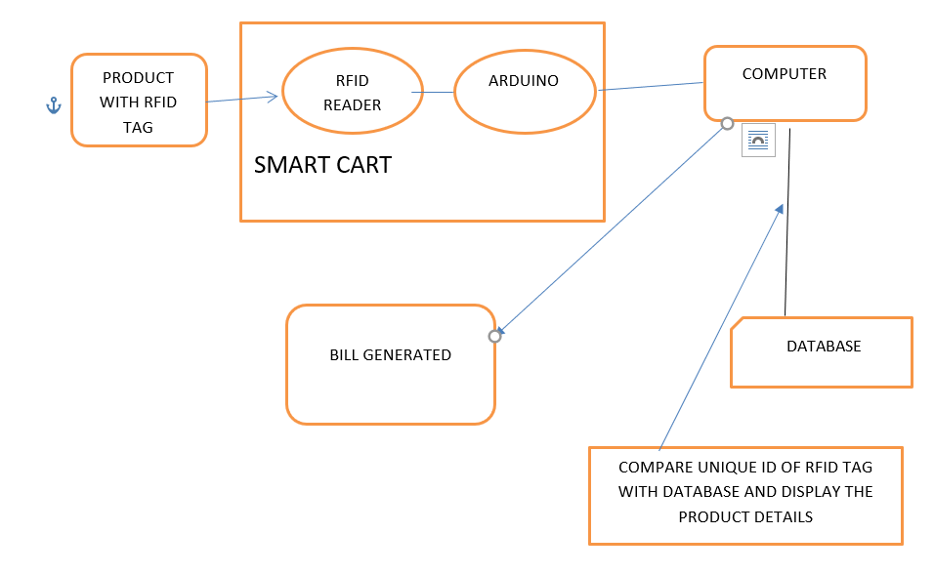
BILLING MODULE
SYSTEM IMPLEMENTATION
CHAPTER 5
SYSTEM IMPLEMENTATION

5.1.OVERVIEW
Predicting the email response time is most helpful since most of the users wait for the response from the another user. Most of the organizations emails are overloaded with lot of emails. In order to avoid such situations, if one knows when they would reply, they would not wait for the response from the user. For finding the response time, some of the algorithms like chain pair extractor algorithm is used.
5.2. MODULES
The modules used in the system are,
- Chain pair extractor algorithm
- Linear Regression
- Logistic Regression
- Support Vector Machine

5.2.1.CHAIN PAIR EXTRACTOR ALGORITHM
First, preprocess the data and extract the objects from the email strings. The features such as from,to, cc,subject, date, content are extracted. From the feature date, extract day, hour, minute and
second separately. After classifying all the features, create a list of same subject and sort the values
according to the time. For finding the response time, subtract the receiver’s sending time and the
sender’s sending time.
15
Figure:5.2.1 Chain pair extractor algorithm.

5.2.2.LINEAR REGRESSION
In this module, the response time along with hour,minute and seconds are classified. For using linear regression scikit’s learn linear regression libraries are used. In order to apply linear regression, which predicts continuous values, given that our labels were discrete values (rounded to the nearest seconds), we rounded the model prediction to obtain a resulting discrete prediction. Linear regression seeks to then learn the parameter via stochastic gradient descent, which minimizes the ordinary least-squares cost function.

16
5.2.3.LOGISTIC REGRESSION
In this module, the response time along with hour,minute and second are classified. For this binary classification of logistic regression is used. In logistic regression, the hypothesis function is the sigmoid function. Then, gradient ascent is used to maximize the log likelihood of the labels given the training examples and learned parameters. For implementing logistic regression, we used scikit-learn’s logistic regression package.

5.2.4.SUPPORT VECTOR MACHINE
The SVM seeks to define a hyperplane that separates training examples of different classes with highest accuracy while also maximizing the margin between the support vectors of different classes (where the support vectors are the vectors parallel to the hyperplane which correspond to points closest to the margin). To make a potentially non-linearly separable dataset separable by a hyperplane, SVM’s will typically map the vector x to a higher dimensional space via a kernel mapping; in our case, we use the Gaussian RBF kernel. This was also implemented with scikit-learn’s SVM package, with a specified Gaussian RBF kernel.

17

RESULT

CHAPTER 6
RESULT
Since email is an unstructured data, extract the email objects out of the single string. For preprocessing the data, email package in python is used for extracting the objects.
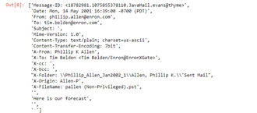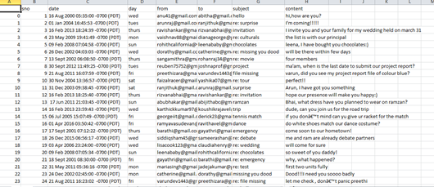
Fig 6.1: Preprocessing and structuring the dataset

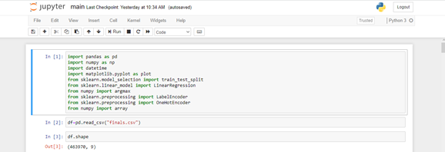
Fig:6.2. Importing the dataset

18
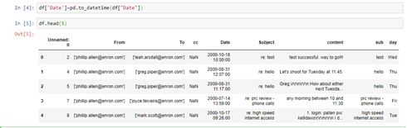
Fig:6.3. Changing the date to standardized form and printing the sample dataset

Fig:6.4: Removing the duplicates in the column from,to,subject,content

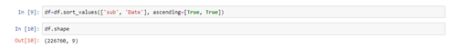
Fig 6.5: Sorting the subject in ascending order and date in descending order

Fig 6.6: Adding a new column to the dataframe

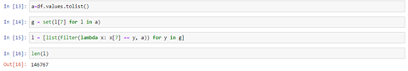
Fig 6.7: converting the dataframe to list and sorting the list according to subject

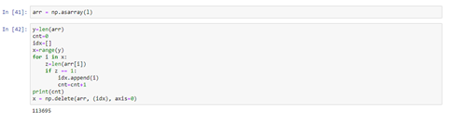
Fig 6.8: Converting list into array and delete the data with no reply
19
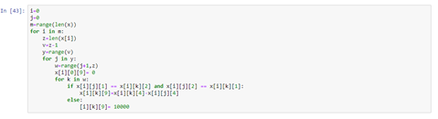
Fig 6.9: Predicting the response time of the email

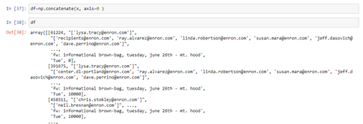
Fig 6.10: Converting multidimensional array into single dimensional array

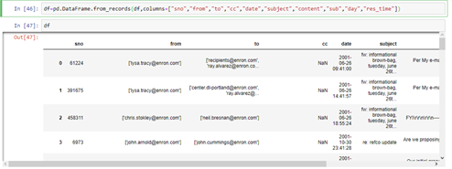
Fig 6.11: Converting the list into dataframe

Fig: 6.12: Converting response time to seconds

20
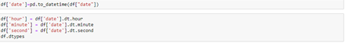
Fig: 6.13: Separating hour,minute,second from date

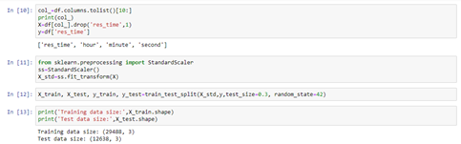
Fig: 6.14: Separating training and testing data

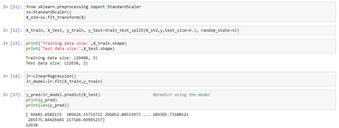
Fig:6.15: Linear Regression

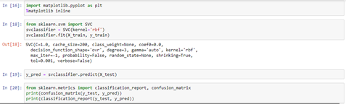

21
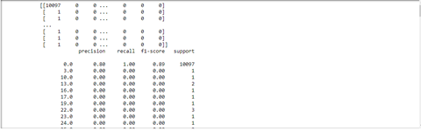
Fig:6.16 Support Vector Machine

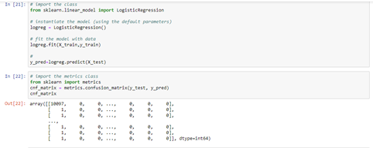
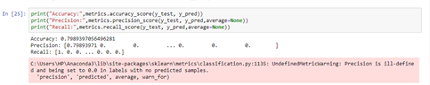
Fig:6.17: Logistic Regression

22

SUPPORT VECTOR MACHINE  SUPPORT: 10097  PRECISION: 0.9  RECALL: 1.0 | LOGISTIC REGRESSION  ACCURACY:0.798653  PRECISION:[0.798653, 0., 0…]  RECALL:[1,0.,0….] | LINEAR REGRESSION  Y-PREDICTION VALUES  [96981.86,385426.17,….,157586.23]

23

CONCLUSION AND FUTURE WORK
CHAPTER 7
CONCLUSION AND FUTURE WORK

Since email is the most important communication tool, predicting the response time will be helpful for the users in an organization. By predicting the response time for an email, the waiting time of the users will be reduced. The important messages will be replied soon. The overload of the emails can be reduced in an organization. So that they can easily reply to all the customers and the colleagues. The accuracy of logistic regression was around 70%. Our future work will be based on characterizing the email with the important words like reply soon, important, fast etc. using natural language processing. Using neural networks, building the layers and increasing the efficiency. With the help of Naïve bayes, using the bag of words, predicting the important words from the email subject and content in order to provide more accuracy.

24

REFERENCES

CHAPTER 8
REFERENCES

[1]Ayodele et. al. Applying Machine Learning Techniques for Email Reply Prediction. 2009.
[2] Drezde et. al. Intelligent Email: Reply and Attachment Prediction. 2008.
[3] Yang et. al. Characterizing and Predicting Enterprise Email Reply Behavior. 2017.
[4] Dredze et. al. Reply Expectation Prediction for Email Management.
[5]Abu-Hakima, S., McFarland, C., and Meech, J.F. (2001) An agent-based system for email highlighting. Proceedings of AGENTS ‘01
[6] Bälter, O. (2000). Keystroke Level Analysis of Email Message Organization. Proceedings of CHI ‘2000, the ACM Conference on Human Factors in Computing Systems.
[7] Belloti, V., Ducheneaut, N., Howard, M., and Smith, I.(2003). Taking email to task: the design and evaluation of a task management centered email tool. Proceedings of CHI ‘2003, t he ACM Conference on Human Factors in Computing Systems

25

